RECIPE OF THE WEEK
GUILT FREE CASHEW CHICKEN
Serves: 3-5
INGREDIENTS
- Cashews – 1/2C
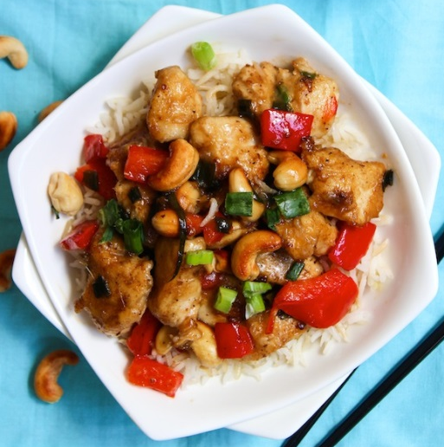
- Chicken breast, cubed – 500g
- Tapioca flour – 1/4C
- Salt – 1/2t
- Pepper – 1/4t
- Red Capsicum, cubed – 1
- Shallots, chopped – 4
- Mushrooms, sliced – 1.5C
- Carrot, sliced – 2 small
- Chicken stock – 1/2C
- Gluten free soy sauce – 1/4C
- Apple cider vinegar – 2T
- Garlic infused olive oil – 2T
- Ginger, minced – 1.5t
- Dates, chopped – 1
- Tapioca flour, for thickening sauce – 1T
- Red chili flakes – 1/2t
- Oil, for frying

METHOD
Toast cashews on stove top by spreading them out in a skillet on medium heat. Move continuously for about 5mins until cashews are brown and emit a nutty aroma. Remove from heat and set aside.
Place tapioca flour, salt and pepper in a small bowl and toss the cut up pieces of chicken to coat lightly. On medium heat in a large, greased skillet add chicken and brown each side. Lower the heat and add diced red pepper and shallots, stirring occasionally.
While chicken cooks, add chicken stock, soy sauce, vinegar, oil, ginger, date and red chili flakes to a blender and blend until smooth.
Transfer sauce to a saucepan and bring to a simmer on medium-low heat. Whisk in tapioca flour and allow sauce to thicken. After sauce thickens pour over chicken mix, add the cashews and bring everything to a simmer on medium-low heat for 2-3mins.
Serve on a bed of rice.

